NAME: Kuldeep Gohil POSSIBLE POINTS: 10

COURSE DATE & TIME:

**Although this lab will be done in groups of 2, each person must submit their own lab report and conduct all the simulations themselves. Only the measurements of the actual components and oscilloscope images may be shared.**

This lab will create a fully functional Regulated 5v Power Supply. We will progress from modeling each of the individual components and entire design on LTSpice to prototyping this proof of concept on a breadboard.

LTSpice Modeling:

**Step 1:** In LTSpice add a voltage to imitate Mains Power. This is a 120Vrms 60Hz AC voltage. Also set the series resistance on the voltage source to 0.0001 ohms and set a label on the output called “Mains”.

Take a screenshot of the waveform with a cursor placed at the peak voltage and also ensure that the screenshot includes the cursor window so that the peak voltage is clearly visible

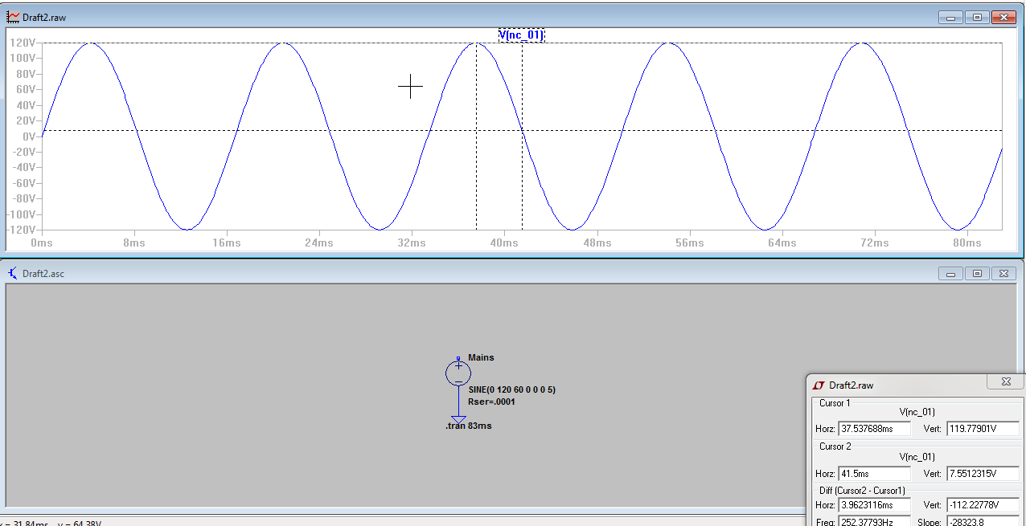

**Step 2:** Now in the lab using the real transformer and the oscilloscope. Take a voltage measurement of your transformer you will be using to construct your power supply (ground clip on one of the outer AC terminal, and probe the other outer AC terminal). Include a picture of your oscilloscope screen that shows approximately 2 cycles. Also use the horizontal cursor to display the voltage and make sure the cursor and value (in the lower right corner) is readable.

Transformer Secondary Windings Peak Voltage: ______38.4V___________

Transformer Secondary Windings Peak-Peak Voltage: ____76.8V__________

We will assume that the Primary Windings actually have 120Vrms as this is a difficult and potentially dangerous measurement to make. No one in class should attempt to probe, touch, or interact in anyway with the mains 120Vrms power.

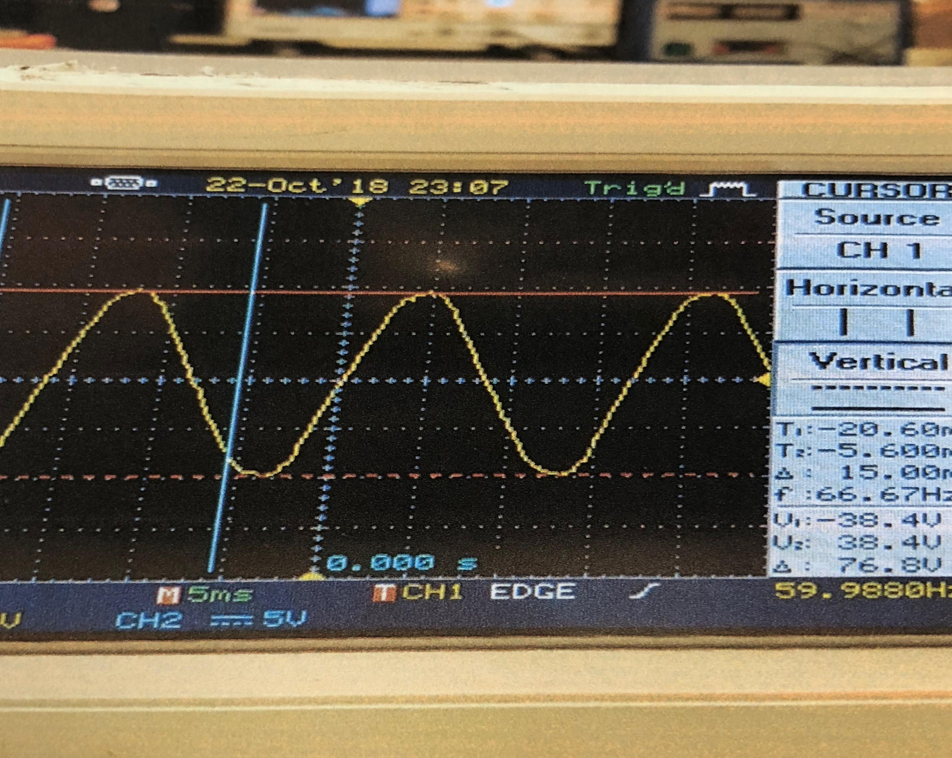

Now calculate the Turns Ratio (i.e. 5:1, 5.2:1 etc..) for the actual transformer you are using assuming a 120Vrms input to the Primary Windings: Show your work below

170Vpk / 38.4V = 4.4

Turns Ratio: 4. 4:1

**Step 3:** In LTSpice create a transformer that has the same Turns Ratio that you calculated and attach to the Mains Power from step 1. Label the output from the Secondary Windings as “Secondary”. Run your model again and take a measurement of the output from the secondary windings. You do not need a screenshot yet, just enter the values below.

Transformer Inductor Lp value in henrys:_______100u________

Transformer Inductor Lp value in henrys:______5.2u_________

LTSpice Modeled Transformer Secondary Windings Peak Voltage: _______36.6V___________

LTSpice Modeled Transformer Secondary Windings Peak-Peak Voltage: ____73.2V__________

What is the difference between the values from your actual transformer in Step 2 vs the modeled transformer step 3?

Peak Voltage Difference (actual - modeled): ______38.4V – 36.6V = 1.8V____________

Peak-Peak Voltage Difference (actual - modeled): _____76.8V – 73.2V = 3.6V_________

Now, do your best to adjust the LTSpice modeled transformer to behave the same as your actual transformer. This will require some trial and error.

New Transformer Inductor Lp value in henrys:______100u_________

New Transformer Inductor Lp value in henrys:_______5.203u________

New LTSpice Modeled Transformer Secondary Windings Peak Voltage: ______38.4V____________

New LTSpice Modeled Transformer Secondary Windings Peak-Peak Voltage: ___76.8V__________

Take a screenshot of the new adjusted transformer waveform with a cursor placed at the peak voltage and also ensure that the screenshot includes the cursor window so that the peak voltage is clearly visible.

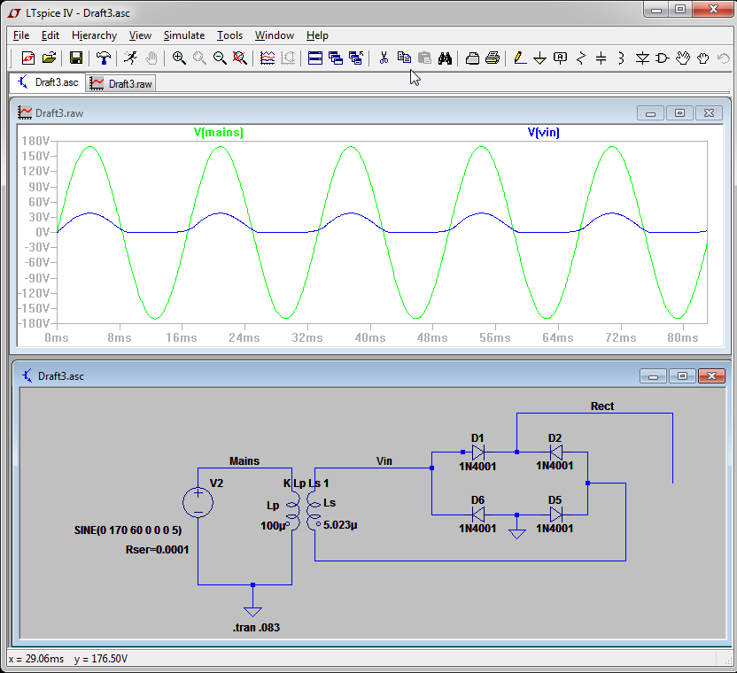

**Step 4:** In LTSpice, now contruct a Full-Wave Bridge Rectifier using 1N4001 Rectifier Diodes. Label the positive output from the rectifier as “Rect”. Take a screenshot of the schematic and waveform. The waveform should show 5 cycles of “Mains” and “Rect” Take a differential voltage measurement of “Mains” and “Rect”. This should show the voltage drop of the rectifier.

Peak Voltage of Mains Signal:_________170V______

Peak Voltage of Rect Signal:_________37.1V______

Calculated Voltage drop on the Rectifier:_____0.7V__________

Frequency of the output from Secondary Windings:______60.007Hz___________

Frequency of the Rectified Voltage:________120.48Hz_________

-Include Screenshot Here-

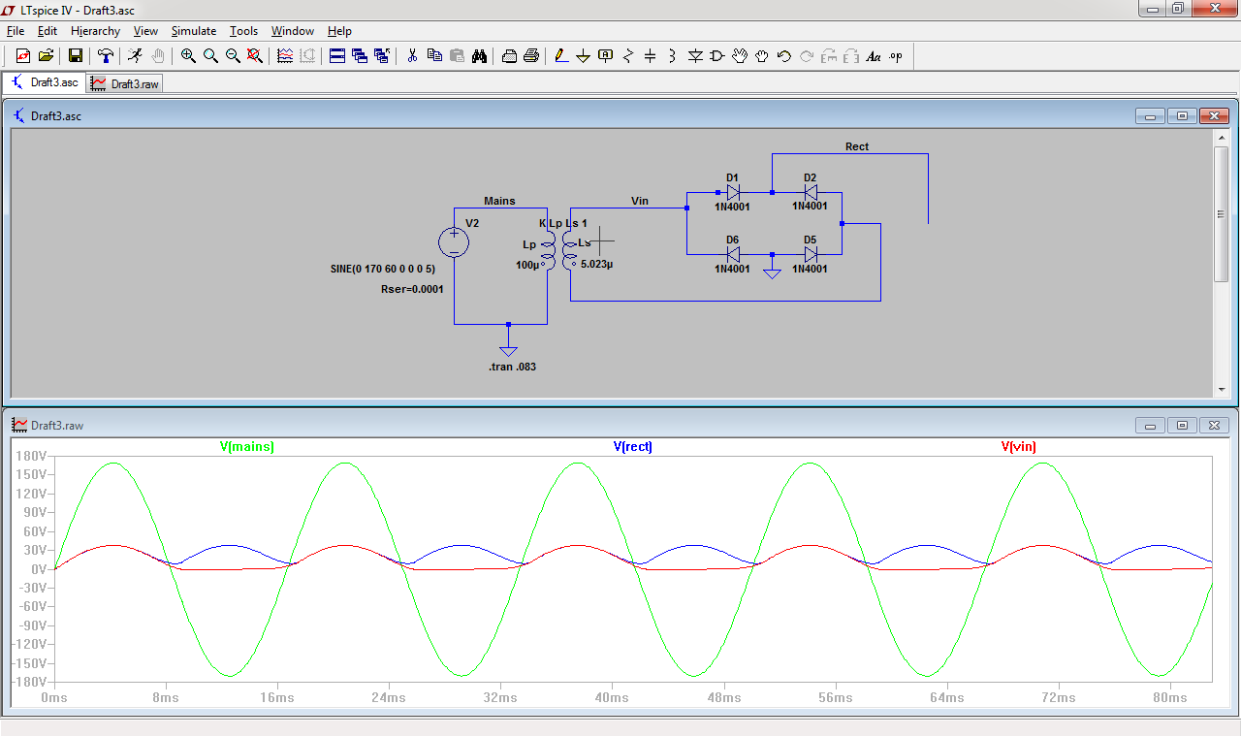

**Step 5:** Now construct the actual Full-Wave Bridge Rectifier on your breadboard. Attach the Transformer to the Rectifier. Now use the oscilloscope with 2 channels to measure both the output from the Secondary Windings and the Rectifier. Use the horizontal cursors on both the Secondary Windings and the Rectified voltage. Take a picture that shows approximately 2 cycles of the secondary signal with the peak differential voltage clearly displayed in the lower right hand corner using the horizontal cursors. The output from the Rectifier is **Pulsating DC.**

Measured Frequency of Secondary Windings:_________N/A_______________

Measured Frequency of Rectifier:_______119.9 Hz________________

Measured Peak-Peak Voltage of Secondary Windings:_________N/A_______________

Measured Peak-Peak Voltage of Rectifier:__________39.2V______________

Measured Peak Voltage of Secondary Windings:__________N/A______________

Measured Peak Voltage of Rectifier:_________38.4V_______________

**Step 6:** Now we need to turn the Pulsating DC into something resembling DC i.e. Smoothed… In LTSpice, add a 2200uF Cap and 100 ohm Load Resistor. We sometimes call this capacitance “Bulk Capacitance” or a “Smoothing” Capacitor… Take a screenshot of the waveform showing the two signals, Rect and Secondary. Take a differential voltage measurement on the Rect signal, with the 2 cursors on the Min and Max voltage, this is Vripple - Ripple Voltage, make sure these measurements are visible in screenshot.

Measured Peak Voltage of Rect:________37.6V___________

Measured Peak-Peak Vripple:________36.87V___________

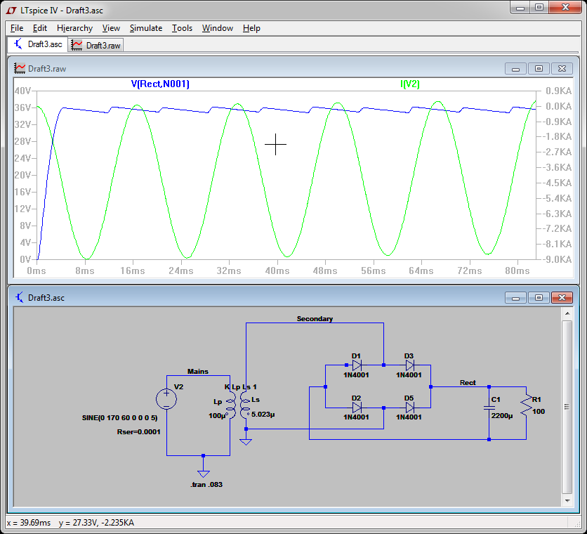

Calculate by hand and show all work and the equation for the theoretical approximate Vripple given the values we are using, make sure to use the Measured Peak Voltage of Rect:

Theoretical Vripple:_______________________

Difference of Theoretical Vripple vs Measured:_____________________________